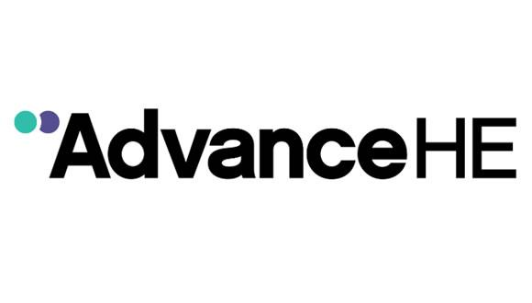

Associate Fellowship Guidance
via
Queen’s Merit Award

Associate Fellow Guidance Notes
January 2024

Contents
1. Introduction 2
1.1 Higher Education and eligibility for Associate Fellowship 4
2. The Professional Standards Framework 2023 (PSF 2023) 5
3. Developing your application 8
Step 1 10
Step 2 10
Step 3 11
4. Your Account of Professional Practice 11
4.1 Your Account of Professional Practice is a personal account 12
4.2 Context Statement 13
4.3 Structuring your Reflective Narrative 13
4.4 Reflective Narrative word limit 14
4.5 Reflect on your practice throughout your Reflective Narrative 14
4.6 Reference list 15
5. Evidencing the required PSF 2023 Dimensions for Descriptor 1 16
5.1 Examples of practice for each Area of Activity 17
6. Supporting Statements 23
6.1 Guidance for referees 23
7. Submitting your Associate Fellowship application via MyAdvanceHE 24
7.1 Application submission process: 24
8. How will your application be reviewed? 24
8.1 How do the reviewers reach their judgement? 25
8.2 How long will the review process take? 25
8.3 Review process and possible outcomes 25
8.4 Outcome of first review 26
8.5 Outcome of second review (resubmission) 27
9. What if I have other questions? 27

1. Introduction
These guidance notes are for individuals wishing to make a application to Advance HE for Associate Fellowship using the Professional Standards Framework (PSF 2023) and via the Queen’s Merit Award.
This document explains Advance HE requirements for Associate Fellowship and provides guidance to support you to develop your application.
Associate Fellowship is the appropriate category of fellowship to professionally recognise individuals from a wide variety of different contexts whose higher education (HE) teaching and/or support for learning practice enables them to evidence some of the PSF 2023 Dimensions to meet the requirements of PSF 2023 Descriptor 1.
By applying to become an Associate Fellow you will have the opportunity to:
+ Demonstrate your commitment to teaching, learning, and the student experience, through engagement in a practical process that encourages research, reflection and professional development
+ Gain professional recognition for your higher education teaching and/or support for learning practice that is increasingly recognised by international institutions
+ Benchmark your practice against professional standards and sector expectations
+ Identify and celebrate your strengths and achievements through reflecting on your experience
Individuals applying for Associate Fellowship may be fairly new to a role in teaching and/or support for learning or may have a limited teaching portfolio; for example, some sessional/ part time staff or early career researchers with some teaching responsibilities. They may be new or experienced staff with specific roles in supporting HE learning such as technicians, librarians, professional staff, learning technologists, careers advisors, etc. It is not role dependent; you will need to explore whether you have sufficient evidence of appropriate teaching and or/support for learning practice to make a successful application.
We recommend that prior to starting your application you use our free online Fellowship Category Tool (FCT). Answering the online questions about your higher education teaching and/or support for learning practice should:
+ help you to check that Associate Fellowship is the best match for your current practice
+ prompt your thinking about different aspects of your practice as you plan your application.

1.1 Higher education and eligibility for Associate Fellowship
The PSF 2023 sets out the professional standards for higher education (HE). All the experience and evidence included in an application for Associate Fellowship must relate to teaching and/or support for learning practice related to higher education provision, such as:
+ | level 4 or above within the Framework for Higher Education Qualifications (FHEQ) in England, Wales and Northern Ireland, or equivalent;
+ | level 7 or above within the Scottish Credit and Qualifications Framework (SCQF) in Scotland on the Framework for Qualifications of Higher Education Institutions (FQHEIS) or equivalent;
+ | level 5 or above of the European Qualifications Framework;
+ | first cycle or above of the Qualifications Framework in the European Higher Education Area (QF-EHEA);
+ | level 5 or above of the Australian Qualifications Framework (AQF) or equivalent;
+ | level 5 or above of the New Zealand Qualification Framework (NZQF) or equivalent;
+ | other equivalent higher education frameworks;
+ | activity focused on supporting learners within a Higher Education context, providing the learner(s) are enrolled on a Higher Education Qualification may also be considered as evidence equivalent to the higher education frameworks above;
+ | delivery of some non-accredited continuing professional development for academic and learning support staff may also be considered as evidence equivalent to the higher education frameworks.
The PSF 2023 acknowledges the wide variety of local and global contexts in which higher education operates, and the diverse practices and roles that contribute to high-quality learning.
In defining what constitutes higher education teaching and learning within different national contexts in order to determine eligibility for fellowship, Advance HE uses UK ENIC (UK National Information Centre) for information about global education frameworks and qualifications. Programmes will be defined as HE for the purposes of staff teaching and supporting learning on the programme being eligible for fellowship if they are an integral part of a programme defined as higher education within the context of the country of study.
The definition of what constitutes higher education has been further defined for staff in UK and Australasia. If you are unsure whether the examples of practice within your application meets the eligibility requirements above, please contact fellowship@advance-he.ac.uk

2. The Professional Standards Framework 2023 (PSF 2023)
The Professional Standards Framework 2023 (PSF 2023) for teaching and supporting learning in higher education provides a comprehensive set of professional standards and guidelines for all those who are involved in teaching and supporting learning in higher education. The PSF 2023 can be used by individuals to plan their development and evidence their practice to achieve professional recognition, by institutions as a basis for initial and continuing professional development and recognition programmes, and at a national level to improve teaching quality and celebrate success.
The PSF 2023 acknowledges the wide variety of local and global contexts in which higher education operates, and the diverse practices and roles that contribute to high-quality learning.
The Professional Standards Framework (PSF) 2023 consists of two components: Descriptors and Dimensions.
Figure 1: Professional Standards Framework (PSF) 2023
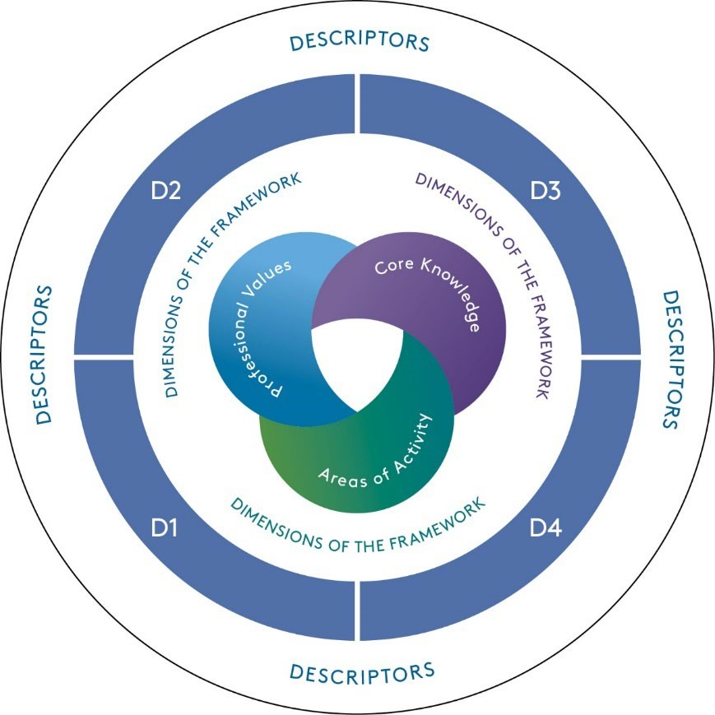
The PSF Descriptors (PSF, p6) are a set of criteria statements (referred to as Descriptor ‘criteria’). These define the key characteristics of four broad categories of practice.
Incorporating the Dimensions, each Descriptor identifies the extent of practice required to meet it and recognises the variety of practice and roles undertaken by professionals who teach and/or support learning. Each Descriptor consists of an introduction and a set of three criteria statements.
The Dimensions of the Framework (PSF 2023, p4) are arranged as three related sets of five Professional Values, five forms of Core Knowledge and five Areas of Activity.
Professional Values (V1-5): underpin all forms of Core Knowledge and Areas of Activity. They are the foundation of professional practice.
Core Knowledge (K1-5): informed by the Professional Values, representing key forms of knowledge required to undertake the Areas of Activity. There are multiple and diverse forms of knowledge which are connected to and shaped by communities and contexts.
Areas of Activity (A1-5): bring together the Professional Values and forms of Core
Knowledge, showing the essential activities that support delivery of effective practice.
Advance HE operates the fellowship scheme and aligns its fellowships to the PSF 2023 Descriptors as follows:

+ Descriptor 1 (D1) aligns to Associate Fellow
+ Descriptor 2 (D2) aligns to Fellow
+ Descriptor 3 (D3) aligns to Senior Fellow
+ Descriptor 4 (D4) aligns to Principal Fellow
An individual providing teaching and/or support for learning can be recognised by Advance HE depending on their professional practice and experience at one of four categories of fellowship. This guidance document is focussed on Associate Fellowship (Descriptor 1).
To achieve Associate Fellowship, you need to evidence that your teaching and/or support of learning practice demonstrates the requirements of the three Descriptor 1 (D1) criteria, which are as follows:
Descriptor 1 is suitable for individuals whose practice enables them to evidence some Dimensions. Effectiveness of practice in teaching and/or support of learning is demonstrated through evidence of:
+ D1.1: use of appropriate Professional Values, including at least V1 and V3
+ D1.2: application of appropriate Core Knowledge, including at least K1, K2 and K3
+ D1.3: effective and inclusive practice in at least two of the five Areas of Activity
As shown above, the Descriptor 1 criteria statements incorporate specified Dimensions; the 15 PSF 2023 Dimensions are shown below in Figure 2.
Figure 2: PSF 2023 Dimensions of the Framework
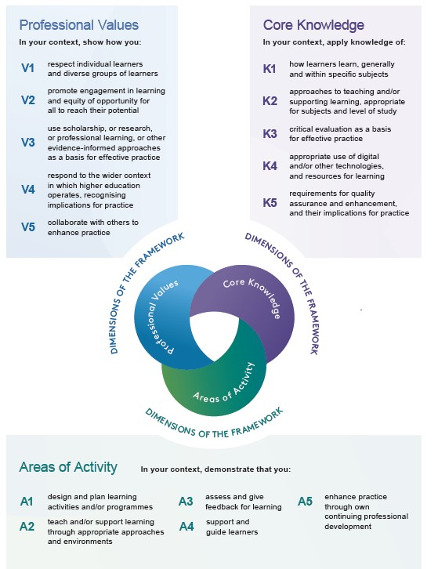

3. Developing your application
In planning and developing your application, we recommend that you follow the sequence of activities set out in Figure 3 below.
Steps in developing your application via the supported route

Experiential Route
Neither the courses nor mentors are mandatory but rather they are recommended, however we recognise that not everyone is starting from the same place, so support is there for those who need it. Once you have decided the route for you, you will register for the Queen’s Merit Award through the Queen’s Merit Award website, where you will be guided through each stage of the process.

A pre-requisition for either route is a minimum of 20 hours teaching inside an academic year in the past three years.

Step 1
Section 2 above explains the Professional Standards Framework (PSF) 2023. Your application will be reviewed against Descriptor 1 of this framework.
Before starting to use this guide, we advise you to complete the Advance HE Fellowship Category Tool (PSF 2023 version), which is free to use on the Advance HE website here.
The Fellowship Category Tool (FCT) consists of a set of statements that are aligned to the different PSF 2023 Dimensions of the Framework and Descriptors. This self-analysis tool will ask about your professional activities in teaching and/or supporting learning in higher education (HE). By using the tool to consider your current and recent practice, your choice of statements as you progress should help to confirm that Associate Fellowship is the most appropriate category of fellowship for you. Please note that the accuracy of the tool depends on the choices you select as you work through it. As you look through the guidance documents, if you feel that you are not yet able to provide sufficient evidence for Descriptor 1 then you can use the report provided by undertaking the FCT to guide the development of your practice further before making a successful application.
In the Canvas resources, you will have the following:
+ Guide to the PSF 2023 Dimensions – Associate Fellowship
+ Associate Fellowship Applicant Guidance (this document)
+ Associate Fellowship Draft Application Template
+ Guidance for Referees writing a Supporting Statement and associated Supporting Statement Template (for use by your referee)
+ Professional Standards Framework (PSF) 2023

Step 2

Guide to the PSF 2023 Dimensions - Associate Fellowship (D1)
We recommend that you start by reading the Advance HE ‘Guide to the PSF 2023 Dimensions - Associate Fellowship (D1)’. This guide introduces and explains the PSF 2023 and then focuses on each of the 15 PSF 2023 Dimensions to support you in thinking about your practice and identifying potential evidence appropriate to PSF 2023 Descriptor 1 (D1), which is the basis for the award of Associate Fellowship.
This Guide focuses on each Dimension in great detail. We include lots of different examples of practice to reflect the wide range of roles and contexts in which HE practitioners work within the global higher education sector. There are also prompt questions to help you to think about your practice in relation to each Dimension. The questions and examples provided are indicative only and may not be relevant to your practice; you may have different appropriate examples, depending on your own unique context.
The starting point for your application will be to decide which two of the five Areas of Activity are most appropriate to your own practice. You will then be able to focus your use of the Guide on the sections most relevant to you and your context, to start to identify evidence to use in your application.

Associate Fellow applicant guidance
Once you have decided which two Areas of Activity you are going to base your application around, and you have identified how in your context you have used appropriate Professional Values (at least V1 and V3) and applied Core Knowledge (at least K1, K2 and K3) in your practice, you should then start to use this applicant guidance document to understand the format and requirements of the application as well as how to submit an application.

Associate Fellow Draft Application Template
Use this Word document template to write and finalise your draft application offline, prior to using our online application system to submit your application.

Step 3
If attending a course, feedback is available each day for the two weeks. Alternatively if you are doing the experiential route submit your draft application, once finalised, to your referees. They will then be able to use the ‘Guidance for Referees writing a Supporting Statement’ and associated Supporting Statement Template.
When you have your Supporting Statements submit your application, complete with checklist, to qma@qub.ac.uk.

4. Your Account of Professional Practice
There are two parts to your direct application for Associate Fellowship:
+ | written Account of Professional Practice; Context Statement and Reflective Narrative against two PSF 2023 Areas of Activity (see Section 5)
+ | one Supporting Statement (see Section 6)
Associate Fellowship is based on meeting Descriptor 1 (D1) of the PSF 2023 and your Account of Professional Practice is the core of your application.
The Account of Professional Practice consists of a Context Statement (see Section 4.2) and a Reflective Narrative against two PSF 2023 Areas of Activity.
Your Context Statement provides a brief summary of your higher education roles, responsibilities and professional experience and your Reflective Narrative should provide evidence that your professional practice meets the requirements of PSF 2023 Descriptor 1.
Higher education takes many forms and there is considerable variation in the different roles higher educational professionals carry out; for example, in experience, disciplinary background, job role, institutional context, etc. Your Account of Professional Practice is a personal account and its focus throughout should be on your own professional practice; make it personal to your specific, individual and distinctive practice. Your Supporting Statement will verify and endorse that what you write about in your Account of Professional Practice represents your practice in a genuine way (see Section 6).
The award of Associate Fellowship is based on evidence of your effective and inclusive practice; you might briefly mention future plans as part of identifying what has worked well and any changes you plan to make in future, however, your application will be judged on whether your evidence of current and recent practice meets the requirements of Descriptor 1.
In your Reflective Narrative you should include appropriate rationale for the approaches you took and evidence the success and effectiveness of your teaching and/or supporting learning practice. Your Reflective Narrative should be based around real examples from your practice and should make clear what you did, why/how you did it that way and how you know that this was effective.
Writing about the ‘why you did it that way’ will enable you to provide evidence for V3: use scholarship, or research, or professional learning, or other evidence-informed approaches as a basis for effective practice.
Provide selective examples of practice in your Reflective Narrative and ensure they have direct relevance to your claim for Associate Fellowship. The quality of the examples of evidence is much more important than the quantity (see Section 4.3).
Examples should be drawn from current and recent practice (within the last 3 years) and must relate to higher education teaching and/or supporting learning. If you need to refer back to practice from more than 3 years ago, you need to ensure that you focus on how this now influences your current practice.

4.1 Your Account of Professional Practice is a personal account
Think of your application as a ‘claim’; you are making a claim that your work is effective and has a positive impact on student learning. Your application will be reviewed by two experienced peer reviewers and you need to show these reviewers that there is a clear rationale behind the way you work and the choices you make in your practice.
Write in the first person (use ‘I’) so it makes clear what you do/ have done. Try to avoid discussing teaching in general or abstract terms as this moves the application away from being about you and your own personal practice and will not help your personal ‘claim’ against Descriptor 1. If you want to include work you did as part of a team/with colleagues, you need to be clear what your personal contribution was.
Your application must be submitted in English (please refer to the Fellowship FAQ document for further information).
Please note that the QMA application only accepts plain text; remove any formatting from your text and do not include diagrams, images, hyperlinks or any other documents/appendices such as curriculum vitae/resume.

4.2 Context Statement and Aligning your Practice with Strategy 2030
A Context Statement (up to 300 words) and is the first part of your Account of Professional Practice and you should briefly introduce yourself and outline your role(s) and responsibilities in teaching and/or supporting learning in higher education. The information in your Context Statement will help the reviewers to understand the nature of your work and the context in which you practice, before they look at the evidence you provide in your Reflective Narrative against the PSF 2023 Descriptor 1; this section provides the background to your Reflective Narrative and is not ‘assessed’ against Descriptor 1.
In no more than 300 words your Context Statement should:
- Your role at QUB and briefly anywhere else,
- Your educational background (where and what discipline),
- Your students/learners (who are they? UG? PG? Staff? How many would you typically teach at a time? This is important because it should dictate how you teach.
- The setting in which you teach. Lectures/labs/library/tutorials etc.
- Your teaching philosophy.
As neither the Context Statement nor the Queen’s Strategy 2030 sections are assessed parts of your application, you do not need to link this information to the PSF. You are not including any evidence in this section. There is no need to map it or include any references. When you have a draft add it to your application form and send it for feedback.
Focus on your current or recent practice, which should be within the last 3 years. Please remember that your application for Associate Fellowship is based on your higher education practice; if you also work in other teaching or learning roles outside of higher education you should not include this in your application (please refer to Section 1.1 for further information about eligibility for Associate Fellowship).
A statement aligning your practice with the Strategy 2030 (up to 300 words) is the second part of your Account of Professional Practice and you should provide examples under three of the four headings, to demonstrate how your teaching aligns with our Strategy 2030.
4.3 Structuring your Reflective Narrative
The written Reflective Narrative is structured into two sections; you write about your practice in relation to two of the five PSF 2023 Areas of Activity. You should choose to write about the two Areas of Activity that are most appropriate to your own practice (see Section 5 below for further guidance).
As well as covering two Areas of Activity (D1.3), to address D1.1 and D1.2 you also need to make sure that across the two sections of the Reflective Narrative you include evidence that you are effectively using appropriate Professional Values at least V1 and V3; and applying appropriate Core Knowledge at least K1, K2 and K3.
In addition to the mandatory Dimensions required for Descriptor 1, you are likely to also identify other Professional Values that you used and other forms of Core Knowledge that you applied within the examples of practice you are writing about. Where this is the case then make clear why and how you used/ applied these.
Please remember to continue to use the Guide to Understanding the PSF 2023 Dimensions – Associate Fellowship to support you in making links between your practice and the most relevant Dimensions and to choose evidence to include as you develop your narrative.
As you provide evidence against the Dimensions, you should highlight this where applicable. One way to do this is to refer to the Dimension in your text, e.g. (V1) or (K1) etc. Ensure that you only link to the most relevant Dimensions in each case (eg one or two that you have engaged with in a meaningful way in that specific example of practice) and avoid producing long lists of links to Dimensions (e.g. K1, K2, K4, V1, V2, V3) as this will not demonstrate your meaningful engagement with the Dimensions.
When deciding which examples of practice, you are going to use for each of the two Areas of Activity, try to use different examples in each Area that best evidence the specific
Dimensions required. It is important that you don’t rely on the same examples in each of the two Areas of Activity as this is unlikely to provide sufficient evidence that your practice meets all the requirements of Descriptor 1. Select your examples carefully as too many examples will restrict your ability to demonstrate your effective practice against each Area of Activity in order to make a strong ‘claim’ against Descriptor 1.
Within the limited words available you will not be able to write about everything you do and must be selective about the examples you choose to write about. Select examples that best exemplify your work in each chosen Area of Activity and which also allow you to demonstrate the specific elements of the Professional Values and Core Knowledge required (see Section 4.4 below related to word limit).
4.4 Reflective Narrative word limit
The overall word limit for the Associate Fellow Reflective Narrative is 1400 words plus citations (not part of word count) and overall maximum 2,000 words.
Although you can choose how to spread the balance of the word limit across your Reflective Narrative, we recommend that you should aim to use around 700 words in each of the two sections plus citations.
4.5 Reflect on your practice throughout your Reflective Narrative
Developing your Reflective Narrative requires you to identify/gather and consider evidence of your practice, reflecting on the impact you have made on student learning. You should avoid long descriptions of what you ‘did’ and take a reflective stance so that it is clear what you did, how/why you did it that way, how you know this was effective and what you will do in future as a result.
A simple reflective model for you to use throughout your Reflective Narrative could be to clearly explain:
+ What you did (be selective with the examples you choose to include – see Section 4.3)
+ Why you did it in this way; clearly explain your approach and justify your choices and decisions (eg use of an appropriate evidence-informed approach to suit your context, etc.)
+ How you carried out this approach (eg including any specific challenges or practical issues you had to overcome)
+ How you evaluated the effectiveness of what you did (explain the kinds of ‘information’ you used to review and evaluate your work including the impact this had on your learners’ learning)
+ What changes you made as a result of evaluating your effectiveness (for example, you might have modified a session in response to learner/ peer feedback and then evaluated the effectiveness of the change you implemented).
4.6 Reference list
Throughout your Reflective Narrative you will refer to the sources of information that you have drawn on within your teaching and/or support for learning practice. For example, K2 requires that you bring to your practice a knowledge base of approaches to teaching and/or supporting learning, appropriate to your context. In evidencing K2, you might explain why you chose an approach and how you came to know about it (e.g. journal article, professional development, conference, mentoring from colleagues, etc.).
Where you do refer to a source of information that has influenced your practice, you should ‘cite’ the reference within your text to provide appropriate credit to the author(s)/organisation. This will enable those reviewing your application to be clear about which sources have influenced and inspired your practice. Whenever you cite in the text, you need to include the full reference in a list at the end of your Reflective Narrative. Please note that footnotes are not accepted by the online application system.
The short excerpt of an Associate Fellowship application below illustrates how the applicant cites the journal article that inspired their design of a lecture and includes the full reference in their Reference List:
‘When it came to designing my seminar sessions, I was influenced by
Burgstahler’s (2015) theory of universal design. I thought about the diverse nature of learners in my group and the cultures and educational backgrounds they came from, to ensure that the activities I chose reflected their identities, interests and needs. (V1)’
Reference List for excerpt
Burgstahler, S. (2015). Equal access: Universal design of instruction. A checklist for inclusive teaching. Seattle: DO-IT, University of Washington. Available at http://www.washington.edu/doit/Brochures/Academics/equal_access_udi.html (accessed 14/02/23)

5. Evidencing the required PSF 2023 Dimensions for Descriptor 1
Deciding which two Areas of Activity to base your Reflective Narrative around is an important first stage in planning and developing your application.
You should use the ‘Guide to the PSF 2023 Dimensions – Associate Fellowship (D1)’ to support you to select the two Areas of Activity in one of the following ways:
+ | consider the guidance and prompt questions for all five Areas of Activity and then make a choice when you have mapped out your likely evidence against each one. You will then be able to decide which two Areas of Activity will make the strongest claim against Descriptor 1; or
+ | alternatively, it may be very clear to you immediately that your evidence is associated with two specific Areas of Activity because of your context and the nature of your practice; in which case focus your attention on the relevant sections in the guide.
Although the Reflective Narrative for Associate Fellow applications is structured around two of the five Areas of Activity this does not mean that the Areas of Activity are more important than the Professional Values or Core Knowledge PSF 2023 Dimensions.
As well as using the ‘Guide to the PSF 2023 Dimensions’ to identify your two Areas of Activity, you should also use the guide to identify where you use Professional Values and apply Core Knowledge within your practice.
Across the 1,400 words of your Reflective Narrative, as well as evidencing two Areas of Activity, you need to ensure that your evidence includes use of appropriate Professional Values at least V1 and V3, and application of Core Knowledge at least K1, K2 and K3.
You will probably have evidence of your practice that includes some other Dimensions in addition to those that are required for Descriptor 1; you can include evidence of some of these additional Dimensions in your application where they are most relevant (see Section 4.3).
The Dimensions are inter-dependent and integrated within the context of your professional practice; put simply, the Areas of Activity are what you do, you use the Professional Values to inform and underpin your work and the Core Knowledge is what you need to apply to effectively carry out this work.
Professional
Values at
least V1 and
V3
2
of the 5
Areas of
Activity
Core
Knowledge at
least K1, K2
and K3
Figure 4: Illustrating how the
PSF 2023 Dimensions are
integrated within Descriptor 1

Associate Fellowship (Descriptor 1)
A short example is given below to illustrate how this might happen in your work:
In designing and planning a learning activity (A1) I apply my knowledge of how my learners learn within this subject (K1) and select an appropriate teaching and learning approach (K2). I consider the needs of individuals within my learner group (V1) and plan appropriately to ensure that all learners will be able to fully engage (V2). I develop appropriate resources to use and set up an online quiz to assess the learning that has taken place in this session (K4, A3).
5.1 Examples of practice for each Area of Activity
The ‘Guide to the PSF 2023 Dimensions’ is your key source of information about what evidence of your effective and inclusive practice (D1.3) you might include in your application for Associate Fellowship.
The short examples below are included to help you to understand how in an application the planning of evidence around the two Areas of Activity also incorporates use of Professional Values and application of Core Knowledge.

An example to support thinking about A1: Designing a short series of study skills workshops
Hassan recently ran a short series of study skills workshops for first year undergraduate students and decided to use this as one of his examples of evidence towards A1.
Hassan firstly explains how he used his knowledge of study skills in the design and planning of the workshops (K1). He discusses the particular needs of his first year group of undergraduate students and how he considered the diversity of their previous learning experiences and individual learning needs in planning his approach (V1, K2). He outlines the challenges that other tutors have previously encountered in delivering these workshops and discusses how he plans to overcome some of these challenges. He then explains why he felt this was the best approach to take with this group.
Hassan explains how he designed the learning activities to link with the students’ particular discipline (K2), drawing on two articles he read which included research on learning in this field (V3).
Hassan evaluated the sessions by getting the students to give feedback after the final session. He then reflects on what worked well and what didn’t, what he learned from the experience and how he plans to change aspects of next year’s workshop series as a result (K3).

An example to support thinking about A2: Demonstrating in a practical laboratory session
Mia, an early-career researcher, has been demonstrating chemical analysis techniques to a group of second year undergraduate students and supporting them to use these techniques in a series of practical laboratory sessions. Mia uses this as part of her evidence towards A2.
Mia knows that second year students find the theoretical knowledge around her subject challenging and understands how useful practical experiments are in supporting them to develop a greater understanding of the subject. She discusses how she used her discipline knowledge (aligning with her research area in this particular case) which underpins the experiment (K2) and refers to relevant pedagogic literature on how learners develop practical skills in her discipline (V3, K1). As this practical lab series is far more advanced than basic first year lab sessions, Mia discusses how she breaks down the practical sessions into clear stages so that she can support students’ engagement and their understanding of the experiment as she works with them, adapting her guidance accordingly (K2).
Mia has considered the diversity of the learning group and discusses how she ensures that all students can participate fully. Some students are mature, some came directly to university at 18, a number of students are from other countries and some of these have difficulties understanding some of the complex language of the discipline. One student has a hearing impairment (V1). Mia provides notes that are available to all students via the VLE about the experiment in advance of the session; these are particularly useful for the students who are working in a second language and the student with a hearing impairment (V2). Mia knows that providing material in advance is important for a variety of students because she attended a CPD workshop on inclusivity, which she found both interesting and useful. As a result of attending this workshop Mia is exploring ways that she can further adapt her teaching practice to ensure that all students are able to engage fully (V2 and V3).

An example to support thinking about A3: Assessing students in a blended learning context
Anton is a post-doctoral researcher with some teaching responsibilities. He is supporting a group of students on a module that is part of a blended learning programme in Art and Design. One of the key aspects of his role is assessing students’ work, particularly formatively, and providing feedback to help them prepare for their summative assessment which ends with a ‘show’. Most of the study on the programme is online, with students attending campus for a one block of learning on a termly basis. Anton uses this as part of his evidence towards A3.
Anton sets the context for his assessment practice and explains the approach he takes to providing formative feedback on the students’ work, relating this to the requirements of the module and the end of year summative ‘show’ (K2). In doing this, he refers to pedagogic literature he has read on assessment and providing appropriate feedback (V3). He discusses the importance of his work in providing timely and supportive formative feedback to enable students to develop their work prior to the final summative assessment.
Anton explains how he works with the challenges and advantages of an online environment to provide his students with appropriate support and guidance (K2, K4). He refers to an interesting article he read about online feedback and explains how this has influenced the way that he now works with students at a distance (V3). This flexible approach to study has attracted some part-time mature students and Anton provides some specific examples of how he has supported the needs of part-time mature students, newly back into study (V1).
Anton then discusses his role in the summative assessment at the end of year show and the way in which he works as part of a team to make assessment judgements on the students’ work (V5). He has taken part in a team development workshop for all tutors on this programme; he identifies what he learned at this session and explains how he now applies this learning when doing the summative assessment at the end of year show (A5). He also discusses some things he intends to do differently next year, based on student progress and mid-module feedback, and why he thinks these changes will enhance learning on the programme (K3).

An example to support thinking about A4: Work-place mentoring
Chen is in a professional role in a clinical setting but is also employed by a university to provide mentoring for undergraduate students in practice. She decides to choose A4 as one of her two Areas of Activity for her application, focussing on her support for a small number of students in a placement setting to translate the learning from their coursework into practice with clients/patients.
Chen discusses her role in mentoring students. She refers to literature on evidence-based practice that underpins both her own clinical work and the students’ work-based learning (V3). She also discusses the training for mentors she attends at the university and explains how she is using some of the examples from those training sessions (V3, A5) to help her provide guidance for some final year students in the clinical setting. Chen discusses the guidance she has created and how this has helped students to apply the learning from their coursework and timely support to prepare for their placement (V2).
Chen demonstrates her understanding of the learning outcomes students are required to fulfil to pass this particular placement (K1) and explains how she and other placement mentors have worked with the module tutor at the university to align the academic elements with the practice context (V5). She provides examples of the kinds of prompt questions she uses with the students to help them think critically about their clinical practice (K1, K2). Chen also encourages students to take histories from patients and then present these so that she can give them some verbal feedback on how they could improve on this and make it more effective (A3).
Chen also considers the particular learning needs of this group of students in comparison to first year students she has mentored in a different setting previously (K1). She discusses the relevance of this particular experience to the students’ future employability and how she ensures that they are clear about how the
Professional Body requirements apply to their work in this clinical context (V4).

An example to support thinking about A5: part-time tutor working within industry and as part of a programme team
Alex is a part time tutor on a postgraduate programme in Film Production. She also works within the industry. She discusses the impact of both her (i) industry-related and (ii) teaching-related professional development on the learning experience she provides for her students.
Industry-related example:
Alex discusses how her continuing professional development in industry supports her role as a tutor on the programme; she remains up to date with current trends in equipment and software through reading professional journals, attending professional development events and working with other professionals. As well as being expert on her own specialist area, Alex explains how her work on film sets across the world enables her to collaborate with other professionals and how she uses the knowledge and insight gained to help her teach from a wider industrybased perspective (K2, V3). She discusses how this impacts on her students’ learning experience and their readiness to work in the global industry (V4).
Teaching-related example:
Alex discusses her commitment to teaching and learning-related continuing professional development. All members of the programme team actively engage in peer-review of teaching and Alex provides several examples of how observing her colleagues and being observed by experienced peers has influenced her approach to her own teaching practice (V3). As a result of these experiences, she has also started to read more about how students learn in her discipline and is drawing on this new knowledge in her teaching practice (K1, K2).
The programme team hold regular meetings and Alex explains how these help her to understand where her sessions fit into the rest of the module and programme (K1). Alex explains what she has learnt about the effectiveness of different methods of teaching from her colleagues’ discussions at the meetings. Together with feedback provided by the student representatives who attend the meetings, and the responses from her module evaluations, Alex has changed some approaches to her teaching and learning practice to enhance some elements of the module (K3).
The examples above will have helped to illustrate how someone might write about their practice in a Reflective Narrative. You will be writing about your own unique context and using examples and evidence personal to you. Remember to write in first person – use ‘I’ – as shown in the short extract below:
I attended a University workshop about neurodiversity in order to better understand the challenges that one of my students faces (V1). I later read an article recommended by the workshop facilitator that was highly relevant to my disciplinary context (V3). I now approach the planning of my session activities and the learning environment to ensure that all my students can fully engage in the learning to reach their full potential (A1, V2).
6. Supporting Statements
Your application for Associate Fellowship must be endorsed by a Supporting Statement from a referee.
The Supporting Statement endorses your claim and is used by the reviewers to confirm that your application presents a fair and accurate reflection of your higher education practice. It is not used by reviewers to fill any gaps in the evidence you provide towards the Descriptor. The reviewers will need to see sufficient evidence of effective practice in your Reflective Narrative to meet Descriptor 1 for them to award Associate Fellowship.
Your referee should work, or have recently worked, closely with you and have first-hand knowledge of your practice so that they are in a position to comment on and endorse your application. Please note that Supporting Statement should reflect a professional relationship; i.e. not be from a family member or based on a personal friendship.
Referees need to have current or recent experience of working in higher education and to be
familiar with the PSF 2023; for example, as a holder of one of the four categories of Fellowship, although this is not essential.
It is important that you read the Supporting Statement your referee provides, as they may refer to aspects of your practice that could strengthen your application; if this is the case then you could revise parts of your application and ask your referee to check that they are happy to endorse the changes you have made before you submit. When you have received your Supporting Statement, copy and paste it from the Supporting Statement template into your application.
You may be asked to provide an alternative Supporting Statement for a variety of reasons when reviewers of your application judge that the statement does not fully verify and endorse the evidence in your application.
6.1 Guidance for referees
Provide your referee with a copy of the Guidance for Referees writing a Supporting Statement – Associate Fellowship and the Supporting Statement template.
In their Supporting Statement, your referee will need to confirm that you have represented your practice accurately and fairly. Therefore, your referee needs to be provided with the final draft of your application to enable them to provide an effective reference. In their Supporting Statement the referee will confirm that in their professional opinion, you demonstrate the requirements of Descriptor 1 and should be awarded Associate Fellowship.
Your referee will be asked to confirm that they have written the Supporting Statement themselves and that the information they provide has been written specifically for your application.
CED reserves the right to contact your referee for clarification so please ensure that the Supporting Statement includes verifiable contact details (eg name, job title, email address, institution). As part of the QMA ongoing quality assurance process, CED routinely checks references for individual authenticity by means of textual review. If the professional integrity of the Supporting Statement is in question, the statement will not be accepted which may result in the application being failed.

7. Submitting your Associate Fellowship application
Once you have finalised your application offline using the Associate Fellowship application template and you have your Supporting Statement, you are ready to submit your application.
Your application is submitted to qma@qub.ac.uk.
7.1 Application submission process:

8. How will your application be reviewed?
Your application will be reviewed by two independent assessors (called a ‘panel’) as part of a peer review process.
The QMA reviewer pool includes education specialists and practitioners from across our institution. Reviewers are selected for their experience of external review and their understanding of the PSF 2023, as well as for their knowledge and experience of learning and teaching in higher education, including different contexts (e.g., disciplines, professional roles, etc.) and global settings.
All reviewers are Fellows, Senior or Principal Fellows and are required to undertake an annual cycle of professional development and regular standardisation activities with Advance HE to ensure that their review of your application is based on their up-to-date knowledge and understanding of the requirements of the PSF 2023 and Associate Fellowship.
8.1 How do the reviewers reach their judgement?
The reviewers will be looking for evidence that your practice meets the requirements of Descriptor 1 across your Reflective Narrative and will check that the Supporting Statement provides appropriate endorsement for your application. They will assess your application against each of the Descriptor 1 criteria.
Please note that the judgement is based on the written evidence you provide in the Reflective Narrative meeting the requirements of Descriptor 1.
Each reviewer will read your application and will apply the Descriptor 1 criteria to reach an initial independent judgement. The two reviewers then reach a combined consensus judgement.
Full guidance for reviewers with associated review pro-formas are available in Canvas. This information sets out the process reviewers follow to make professional judgements on Associate Fellowship applications.

8.2 How long will the review process take?
An application for Associate Fellowship can be made at any time during the year and will be allocated to the next available panel. The length of time it will take to process your application is dependent on the dates of our review panels and the demand on the fellowship service when you submit your application.
QMA holds regular review panels and typically you will be notified about the outcome of your application within 18 weeks.
If your application is not successful following the first review, you will receive feedback from the reviewers and have one opportunity to strengthen your application and resubmit (see below). Once you have resubmitted, you will normally be notified of the final outcome within 6 weeks.

8.3 Review process and possible outcomes
The diagram below outlines the review process for your application and possible outcomes.
Figure 2: Associate Fellowship application review process. ‘1’ indicates first resubmission process; ‘2’ indicates ‘unsuccessful’ outcome for resubmission and end of review process
Application
reviewed by two
Reviewers.
Descriptor 1 met.
Descriptor 1 not met.
Associate
Fellowship awarded.
Consensus
judgement reached.
Applicant has four
weeks to resubmit.
Resubmission
Referred.
End of review
Process.

1
2

8.4 Outcome of first review
There are two possible outcomes following the first review of your application – Award or Refer.

Outcome 1: Award
If the reviewers’ consensus judgement is that your application meets the requirements of Descriptor 1 then you will be awarded Associate Fellowship. You will receive a congratulatory email which will explain how to download your Associate Fellowship certificate from the QMA.
As an Associate Fellow, Advance HE expects you to adhere to the Fellowship Code of Practice and to maintain your professional practice in accordance with the PSF 2023.

Outcome 1: Refer
Should your application be judged as providing insufficient evidence for meeting Descriptor 1, then you will be provided with feedback from the reviewers in a Panel Outcome and Feedback template. This feedback will indicate which of the three Descriptor 1 criteria your application has met and explain how your application needs to be strengthened to provide the evidence of the remaining Descriptor 1 criteria.
You will be offered one opportunity to resubmit within four weeks, you will be asked to highlight any changes you make to your original application. Once you submit your revised application, the same reviewers will make a final judgement to either award Associate Fellowship or that the application is unsuccessful.
8.5 Outcome of second review (resubmission)

Outcome 2: Award
If the reviewers’ consensus judgement on your resubmission is that your revised application meets the requirements of Descriptor 1 then you will be awarded Associate Fellowship.

Outcome 2: Unsuccessful
If the reviewers judge that despite revisions, your resubmission does not fully meet the requirements of Descriptor 1 then the final judgement is ‘unsuccessful’. In this instance, further feedback in Section 4 of the Panel Outcome and Feedback template will explain the unsuccessful judgement.
Please note that Section 1 of the Panel Outcome and Feedback template will be updated to show where Descriptor 1 criteria are met in the resubmission. The original reviewer feedback from the first review will remain unaltered in Sections 2 and 3 of the form; Section 4 will draw on the feedback in Sections 2 and 3 to explain the final outcome.
This is the end of the review process; any future application would incur a full fee.
Please note that any appeal would need to be related to the published Advance HE fellowship review process not being accurately followed and not the outcome of the review.
9. What if I have other questions?
If you have further questions or require further assistance, in the first instance please contact qma@qub.ac.uk

