COSHH Risk Assessment Form

A COSHH risk assessment must be conducted before you commence work which could expose you to substances hazardous to health.

Section 1: Project Details

Undergraduate Practical / Project | Masters | Postgraduate | Postdoctoral | Staff | Other

Group or teaching year:
(if applicable)
School / Centre:
Title of project or activity:
Location of work:
(building and room number)
Principal Investigator / Supervisor:
Person carrying out assessment:
Assessment Date: | Review Date:
Detailed description of work activity:
(Include quantities of substances to be used and how they are to be used i.e., mixed, heated etc.

Section 2: Hazard Summary Section

Hazard pictograms – select all that apply to the work activity
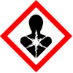 | 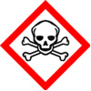 | 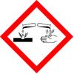 | 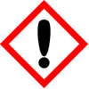 | 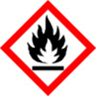 | 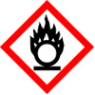 | 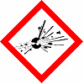 | 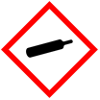 | 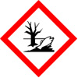
Health Hazard | Toxic | Corrosive | Irritant | Flammable | Oxidising | Explosive | Compressed Gas | Dangerous for the environment

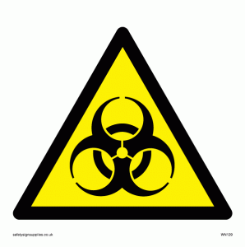 | 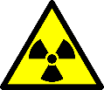
Biological | Radioactive

Section 3: Hazardous Substances Information

List all the substances you are going to use in the procedure you are assessing. All the information required to populate the table below can be found on the manufacturer’s safety data sheet.

If none of the substances to be used are hazardous to health, the risk assessment is complete at this stage and should be signed off.

Name of substance | Hazard Classification* | Physical form  e.g., powder, dust, liquid, gas | Route of exposure e.g., ingestion, inhalation, absorption, injection | WEL (mg/m3) or (ppm)

* Please detail the level of health hazard i.e., Hazard statements and Carcinogenic / Mutagenic categories

Note A separate BioCOSHH / GM / Radiation Risk Assessment may be required depending on the work taking place

Hazards produced during / after reaction / experiment
List all the substances (if any) you are going to produce in the procedure you are assessing and the associated hazards.

How often will this work activity be carried out?
Daily | Weekly | Monthly | Other  (please specify)

How long will the process / work activity last?

Who might be at risk? | Staff | PG | UG | New and Expectant Mothers | Cleaners | Contractors | Public

Risk matrix can be found in Note 1.

Assessment of risk PRIOR to the use of controls | Severity  (1-5) | Likelihood  (1-4) | Overall Risk Rating  (Severity x Likelihood)

Section 4: Controls
If exposure cannot be prevented by using a different process, alternative substances or different forms of the same substance, consider the most effective precautionary measures needed to adequately control exposure which are proportionate to the risk.

Physical or Engineering controls: | Glove Box |  | Fume Cupboard |  | Local Exhaust Ventilation |  |  | Open Doors / Windows |  | Other (please specify)
Administrative controls: (including training requirements
Out of hours controls: (if required)
Personal Protective Equipment: |  | 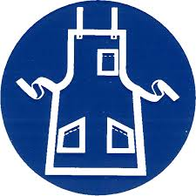 |  | 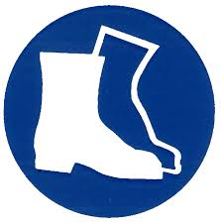 |  |  |  |  |  |  | 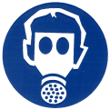
 | Lab Coat | Apron |  | Safety Footwear |  | Gloves* | Face Shield |  | Glasses / Goggles |  | RPE**
Storage requirements:
Disposal procedures:

*If protective gloves are required, please indicate which type is the most suitable for the substance handled.
**A person requiring RPE must be ‘face-fit tested’ to the RPE (Further advice on the selection of suitable RPE and face-fit testing is available from the Occupational Health and Safety Service).

 | Yes | No | Describe the findings of exposure monitoring or health surveillance
Is exposure monitoring required? (See Note 2)
Is health surveillance required?*(See Note 3)

*If yes, please state date of referral to Occupational Health: __________________________

Assessment of risk AFTER the application of controls | Severity  (1-5) | Likelihood  (1-4) | Overall Risk Rating  (Severity x Likelihood)

Section 5: Emergency Procedures

The purpose of this section is to provide easy access to emergency information for First Aid, Spillage and Fire.

First Aid
If inhaled:
In case of skin contact:
In case of eye contact:
If swallowed:

Spillage
Personal precautions, protective equipment and emergency procedures:
Environmental precautions:
Methods and materials for containment and clean up:

Fire
Suitable extinguishing media:
Special hazards arising from the substances or mixture:

Section 6: Contacts

Contact in the event of an emergency:
(first aid, spillage, fire):
Out of hours contact:

Section 7: Approval

I confirm that this is a suitable and sufficient risk assessment for the above described work activity | Name | Signature | Date
Assessor:
Principal Investigator / Supervisor:
COSHH Supervisor:

I have read and understood the information contained in this COSHH Risk Assessment and I agree to adopt the control measures and precautions as stated above:
Name (Printed) | Signature | Date

This assessment should be reviewed at regular intervals and immediately if there is reason to suspect that it is no longer valid (for example after any accidents or incidents) or if there is a significant change in the work to which it relates.

Note 1: Risk Matrix

 |  | Risk Likelihood
Hazard Severity |  | Unlikely (1) | Possible (2) | Likely (3) | Very Likely (4)
Minor (1) |  | 1 | 2 | 3 | 4
Moderate (2) |  | 2 | 4 | 6 | 8
Serious (3) |  | 3 | 6 | 9 | 12
Very Serious (4) |  | 4 | 8 | 12 | 16
Extreme (5) |  | 5 | 10 | 15 | 20

 | Risk Rating
Low | (1-5)
Medium | (6)
High | (8-10)
Very High | (12-20)
Note 2 – Exposure Monitoring
Exposure monitoring provides assurance on the adequacy of your controls. It has nothing to do with the state of a worker’s health.

Note 3 – Health Surveillance
Health surveillance is appropriate where employees are exposed to carcinogenic and mutagenic substances, unless the risk assessment confirms that exposure is so adequately controlled that there is no reasonable likelihood of an identifiable disease or adverse effect resulting from the exposure or the quantities used are so small that even if control measures fail, the exposure is likely to be insignificant. It is also appropriate when the work involves the use of substances known to cause occupational asthma or severe dermatitis or if there is contact with chrome solution, electrolytes containing chromic acid or chromium salts and other substances which can cause skin cancer.

